Integration Project – Dashboard Guide

Integration Project – Dashboard Guide

Admin Guide:
Procedure to refresh data:
Step 1: The data sources for the dashboard are
GS/PS Master Data:
\\Europe.bmw.corp\WINFS\Panama\PLW_TV\PNW2_COC_ASSEMBLY_PLANNING\090_GSPS\02_Country_Specific
(Only refresh India’s data, other countries have to take care of updating their country’s excel)
This Folder contains the data for GSPS Progress of individual countries
01_Brazil
02_India -> This one is linked with the Integration DB
Open the excel, go to data, click Query and Connections, refresh all the 5 datas
- Copy of Qimsys Uniq1
- Copy of Qimsys sub3
- Impl_Q_Status
- Eff_Q_Status
- Comp_Q_Status
If any error comes during refresh, try refreshing , if any error still persists, correct the error and re- refresh. For procedure, check out P:\Department\06_Total_Vehicle_Quality_Management\SHARE\11_Intern Department\36_Sabitha\Notes\IntegrationPANAMA.txt
03_
04_
05_
06_
07_

Class A LOP (No need to refresh)
\\Europe.bmw.corp\WINFS\Panama\PLW_TV\PNW2_COC_ASSEMBLY_PLANNING\090_GSPS\01_Common

Class B LOP(No need to refresh)
\\Europe.bmw.corp\WINFS\Panama\PLW_TV\PNW2_COC_ASSEMBLY_PLANNING\090_GSPS\01_Common

Step 2: After updating all the required data, go to P:\Department\06_Total_Vehicle_Quality_Management\SHARE\11_Intern Department\36_Sabitha\Tableau Dashboard
where the backend Panama Access DB is located.
i.e., only works with Sulaiman Sir’s ID)

Step 3: Open all the individual country queries

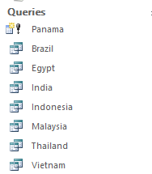
Open Brazil, Egypt, India, Indonesia, Malaysia, Thailand, Vietnam Queries.
There are possibilities of errors like “External Data not available” or “File in use” etc. It appears only if any of the Master Excel files in Country_Specific Folder are in use. Close those files if open or try opening the queries again and again until it look like the below screenshot(all tables should be open)
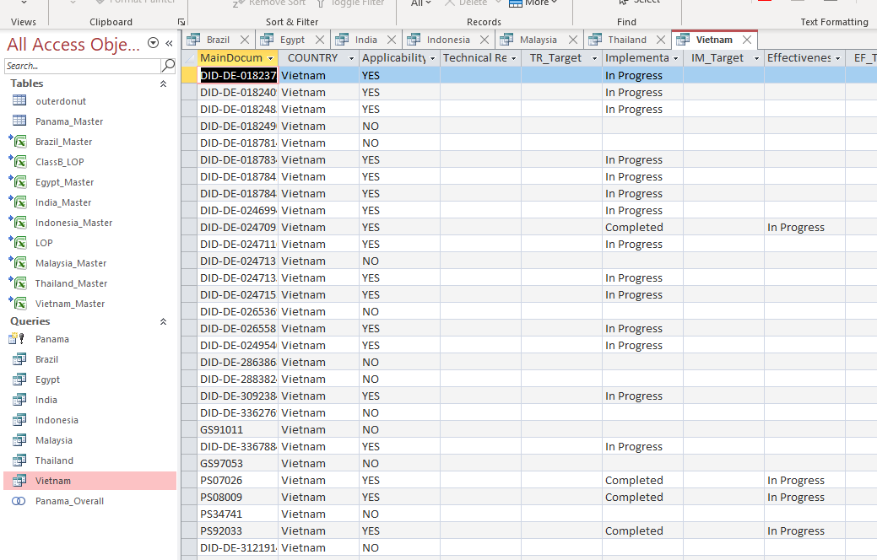
Step 4: Click on Panama (make table query)
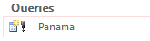
Step 5: This pop-up comes. Click Yes
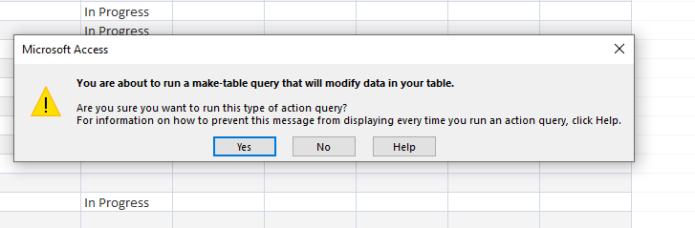

Step 6: This pop-up comes next. Click Yes
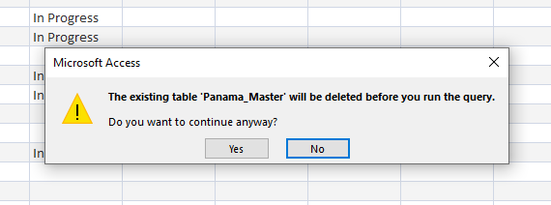
Step 7: This pop-up comes. Click Yes
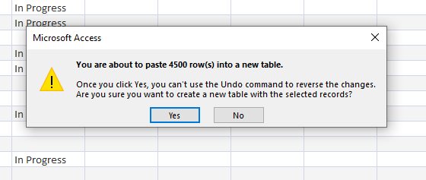
Step 8: Save the DB
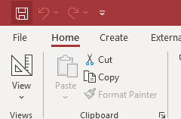

Step 9: Go to Data Analytics Folder
\\asiapacific.bmw.corp\winfs\W20-data\Projects\05_Total_Vehicle_Quality_Management\06_Data_Analytics

(make sure its not P Drive)

Step 10: The Data Sources linked with tableau are
GS PS Master: MASTERLIST_GSPSWI_OVERALL_PNW2.xlsx
ClassA Master: LOP.xlsx
ClassB Master: ClassB.xlsx
(all 3 are in the 06_Data_Analytics folder)
Refresh all 3 Master sheets
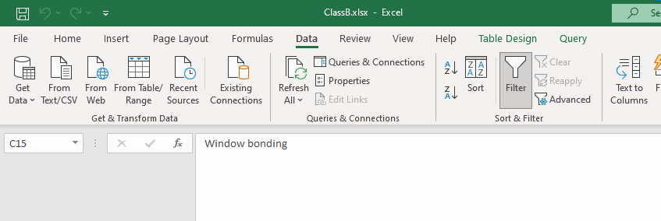
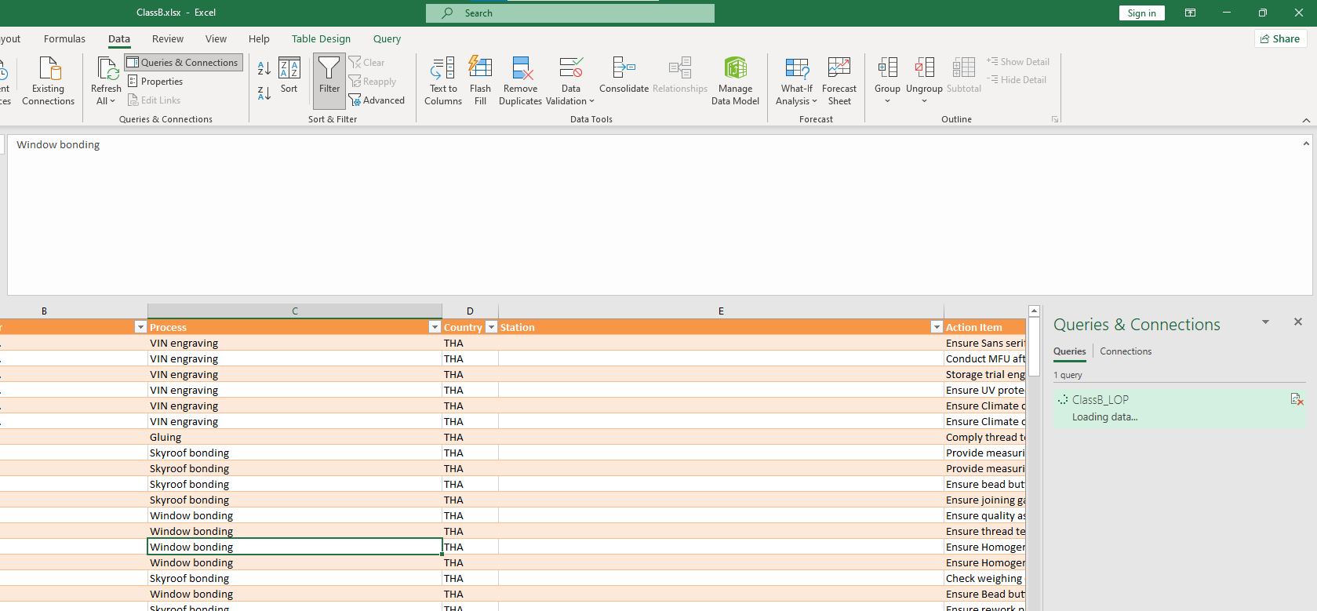
Go to Queries & Connections, click refresh ,if any error, re-refresh till data is refreshed correctly

Step 11: Search for Tableau in Search bar. Right click on it -> Open File location
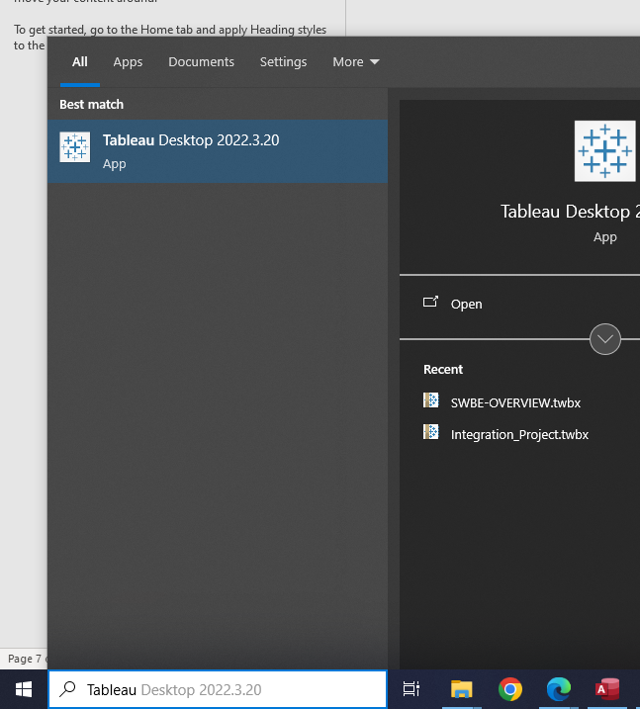

Step 12: Right click on Tableau Desktop 2022.3.20 . Shift Right Click and click Run as Different User. Log in with QQSFM10 id

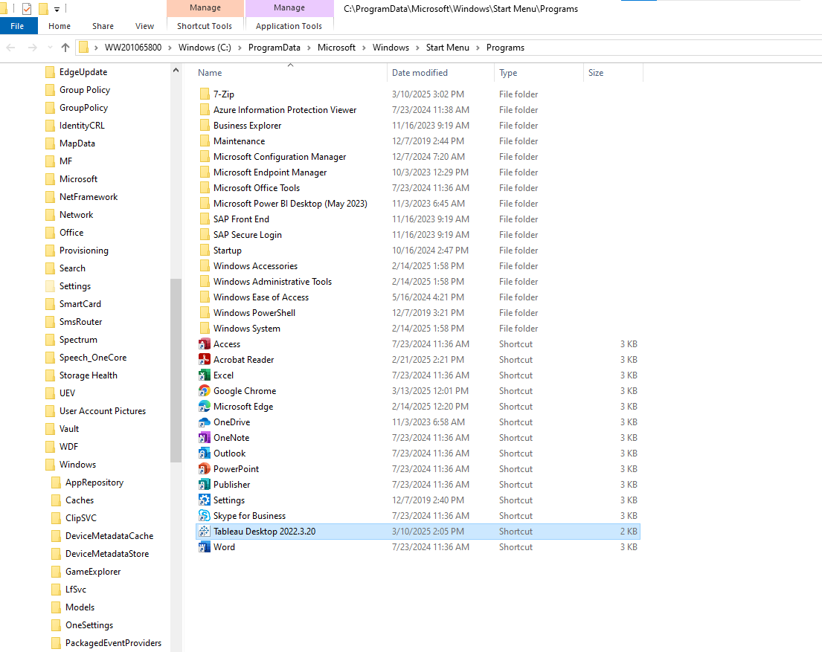
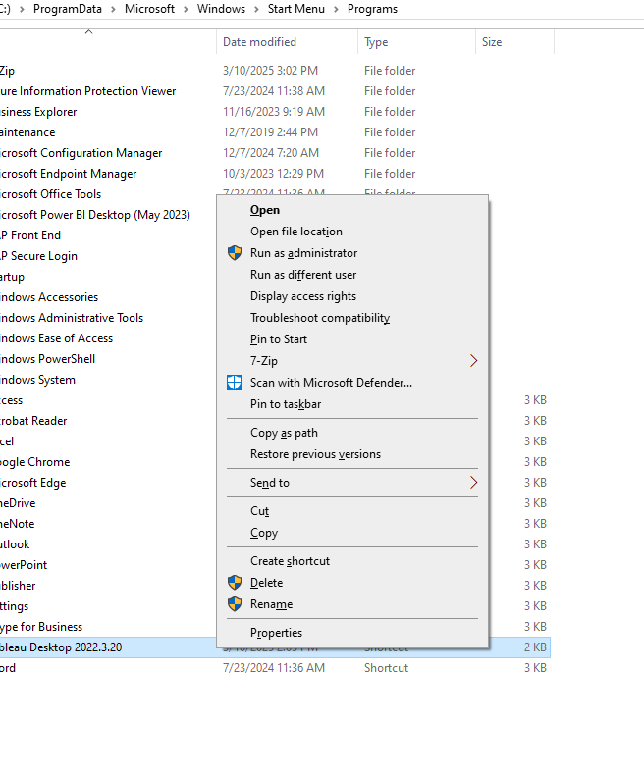
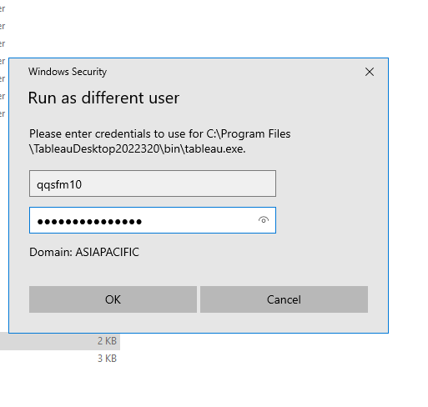
Step 13: Open tab02 Integration_Project. Connect with https://tab02.bmwgroup.net and log in with QQSFM10 ID
New server connection for tableau is https://tab05.bmwgroup.net/
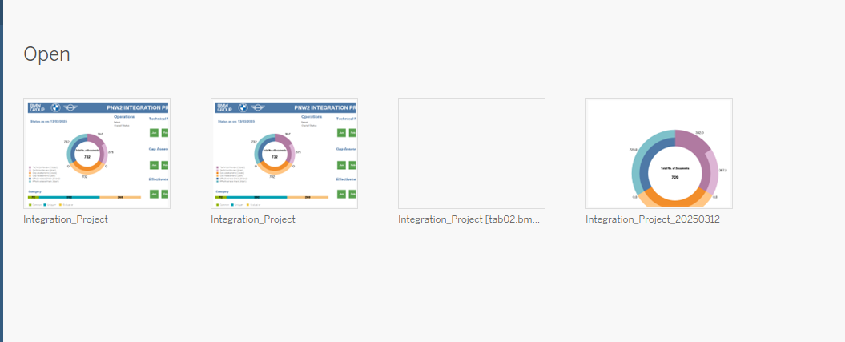

Step 14: In main dashboard, Go to data -> Refresh all extracts and Click Refresh

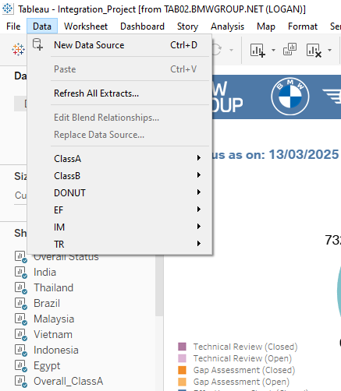
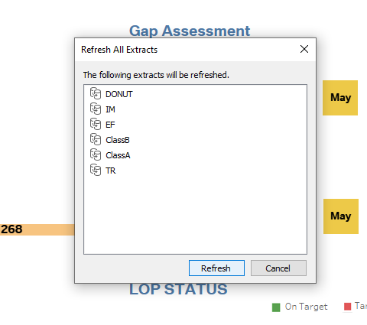
Close after Refresh
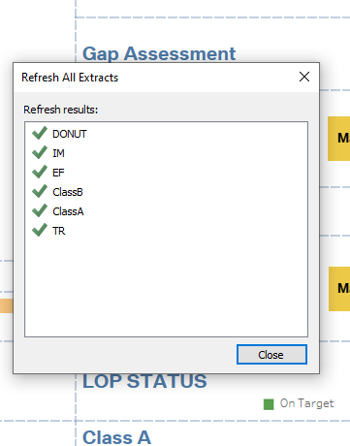

Save the file
C: -> temp

Step 15: Go to Server and Publish Workbook.

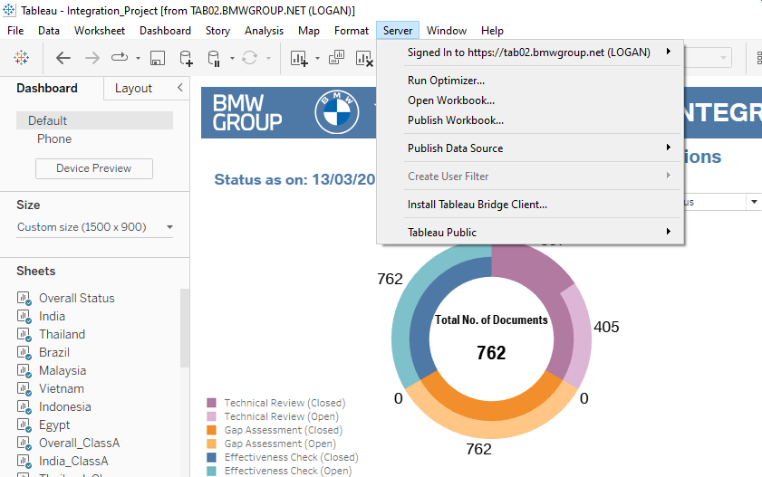

Step 16: Make sure all these below details are correct

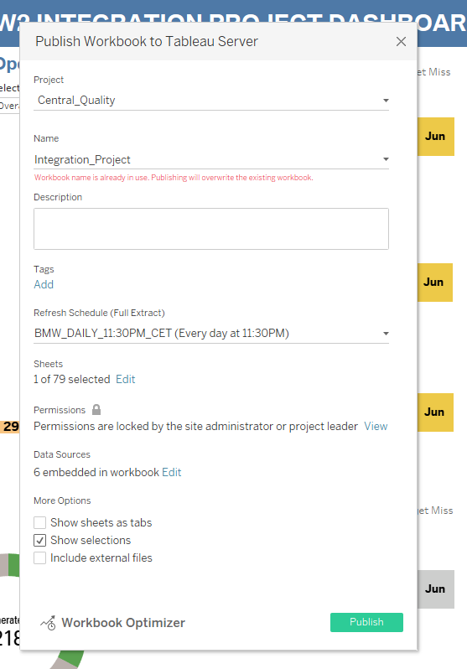
Step 17: Click on Publish

Step 18: Names already in use pop-up . Click Yes and the dashboard will get published

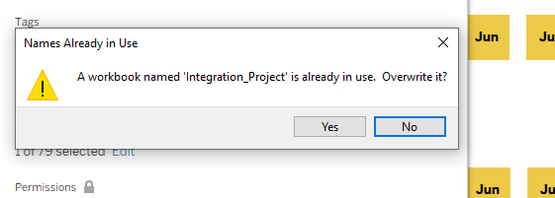

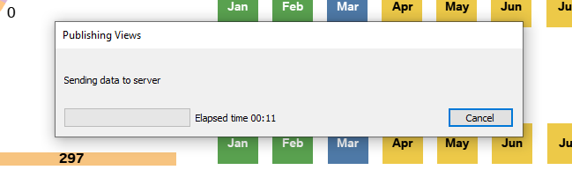

The Dashboard is published. Check if it is live on:
https://tab05.bmwgroup.net/#/site/LOGAN/views/Integration_Project/Integration_Progress_Dashboard?:iid=1&:redirect=auth
(Note: If the dashboard is very slow, clear cache or unnecessary charts in tableau dashboard and republish it)

Learning Points form Tableau
1. Connection Errors
- Issue: Error occurs when connecting to a data source.
- Solution:
  - Check the Data Source connection settings.
  - Ensure there are no hidden files causing the issue.
  - Verify that all necessary documents are properly imported into Tableau.
2. Mismatch in Data Counts
- Issue: Data counts in Tableau do not match expected values.
- Solution:
  - Compare Tableau data with country-specific Excel files.
  - If major discrepancies exist, review and correct the underlying query.
  - For overall country data issues, ensure no data from other countries is mistakenly included.
3. Specific Count Mismatches (EF, TR, Impl, Class A, Class B)
- Issue: Count mismatches in specific categories.
- Solution:
  - Check the Excel files in the country-specific folders.
  - Review the target dates and status fields for accuracy.
4. TV-4 Related Documents
- Issue & Solution: Follow the same procedure as specific count mismatches to ensure data accuracy.
5. GSPS Excel File Errors
- Issue: Errors related to GSPS Excel file counts.
- Solution:
  - Relink the Excel file specific to the country in question.
  - Use Power Query Editor to reference and correct any issues.

Troubleshooting Panama DB Errors in Sabitha Folder
Common Error: Unexpected Data Format
- Issue: Unexpected data format errors occur, often due to inconsistencies in data structure.
- Solution Steps:
  - Open Each Country Individually:
    - Review each country's data separately to locate the source of the error.
    - This process helps isolate which specific country's data is causing the issue.
  - Identify Columns with Errors:
    - Pay attention to any pop-up notifications that indicate which columns have errors.
    - These alerts can guide you to the problematic areas in the dataset.
  - Check Specific Country Files:
    - Navigate to the file for the specific country where the error was detected.
    - Review the column headers and ensure they match expected formats.
    - Verify that the sheet structure and data types are consistent and correct.

